**Segmenting Satellite Images for detection of road, buildings, natural resources**

**Problem Statement**

Image segmentation is one of important trend in image processing. It is a technique which divides or partitions an image into segments. There are various application area for image segmentation mostly are image compression, medical applications, satellite imagery, object recognition etc.. as it is not efficient to process the entire image. Image segmentation segments an image into sub regions of our interest and then those areas can be analyzed individually. There are many techniques for this which partition an image into segments based on certain features like colour, texture, pixel intensity etc... and the categorization of techniques are done based on the method used. Here in this case, the problem statement is that the images received from satellite will be segmented and then road, buildings and natural resources present in the image need to be detected.

**Background**

For image segmentation using CNN (Convolutional Neural Network), there are many model which are used for image semantic segmentation for example- SegNet, it is an architecture for image segmentation based on deep convolutional encoder-decoder. Fully Convolutional DenseNet, this is for semantic segmentation, The One Hundred Layers Tiramisu is an example of it. The other more are E-Net for real-time semantic segmentation and Link-Net, for efficient semantic segmentation it exploits the encoder representations. Few more names like Mask R-CNN, PSP-Net, RefineNet etc..

In this case, U-Net has been chosen which is basically a convolutional auto-encoder and the advantage is that spatial dimensions of input data for training and inference need not be same. It does not need much of the training data to get trained. So, it most of the choice when working with satellite imagery data. Also, it is adaptive in nature as it's architecture is quite similar to PSPNet and One Hundred Layers Tiramisu.

**Methodology**

Architecture of the image segmentation using U-Net is shown in figure 1.

*Step 1: Data collection and dataset preparation*

A small dataset of around 25 satellite image along with corresponding labels of objects like road, natural resources etc... Each image will have 20 useable bands rather than 3 bands. For example, 3 bands represents Red, Green, Blue. 20 bands will have lot more information (which human normally don't see) for neural network to learn and predict. The extra bands are called P, M and A bands. A band has 8 channels, M band has 8 channels and P band has 1 channel.

*Step 2: Augmenting the dataset*

*Step 3: Developing a U-Net (CNN based) Image segmentation model for detecting road, natural resources etc..*

*Step 4: Training and experimentation on datasets*

*Step 5: Testing the model on real time data*

After creating the detection model and tested on test dataset. The model can used to detect roads, buildings, natural resources etc... from the real time images received from satellite.

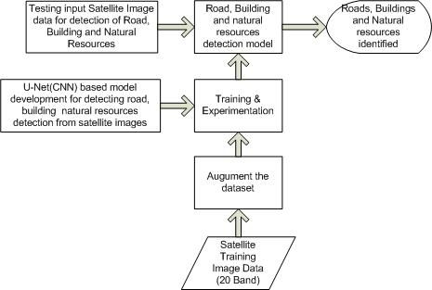

**Figure 1**. Architecture of U-Net model

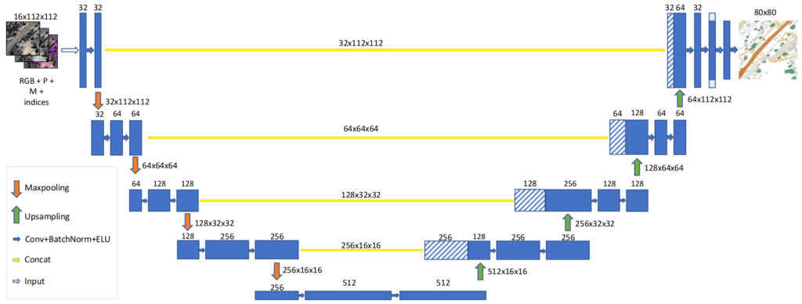

**Figure 2.** Architecture of U-Net Based Image segmentation for detection of roads, building and natural resources from satellite image data [https://vooban.com/en/tips-articles-geek-stuff/satellite-image-segmentation-workflow-with-u-net/]

**Experimental Design**

*Dataset*

Satellite image dataset with 20 Band

*Evaluation Measures*

Warping error, Rand error and Pixel error will be computed for estimating the efficiency of the model.

*Software and Hardware Requirements*

* Image related deep learning libraries
* Anaconda Python
* Deep learning capable machine like NVIDIA GPUs with at least 8 GB or more RAM